**Machine Learning Model Deployment with IBM Cloud Watson Studio**

**Team member**

**732721104060 : Vijitha M**

**Phase 2 Submission Document**

**INNOVATION**



**Introduction:**

* Deploying a customer churn prediction machine learning model through IBM Cloud Watson Studio is a transformative process.
* It begins with data selection and preprocessing, followed by model training using historical customer data.
* Once trained, the model is deployed as a web service, enabling real-time predictions.
* By combining data-driven insights with ensemble techniques, this solution empowers businesses to proactively tackle customer churn, enhancing profitability and customer loyalty through IBM's cloud-based platform.
* It's a streamlined, efficient solution that exemplifies the power of predictive analytics in today's competitive landscape.

**Content for Project Phase 2 :**

Consider experimenting with ensemble methods or hyperparameter tuning to optimize the model's performance.

**Data Source :**

Data source for ML deployment should be accurate, comprehensive, geographically relevant, and easily accessible to ensure a reliable and efficient model.

Dataset link : ( <https://github.com/Dhanusri-P-S/ml-model-datasets> )

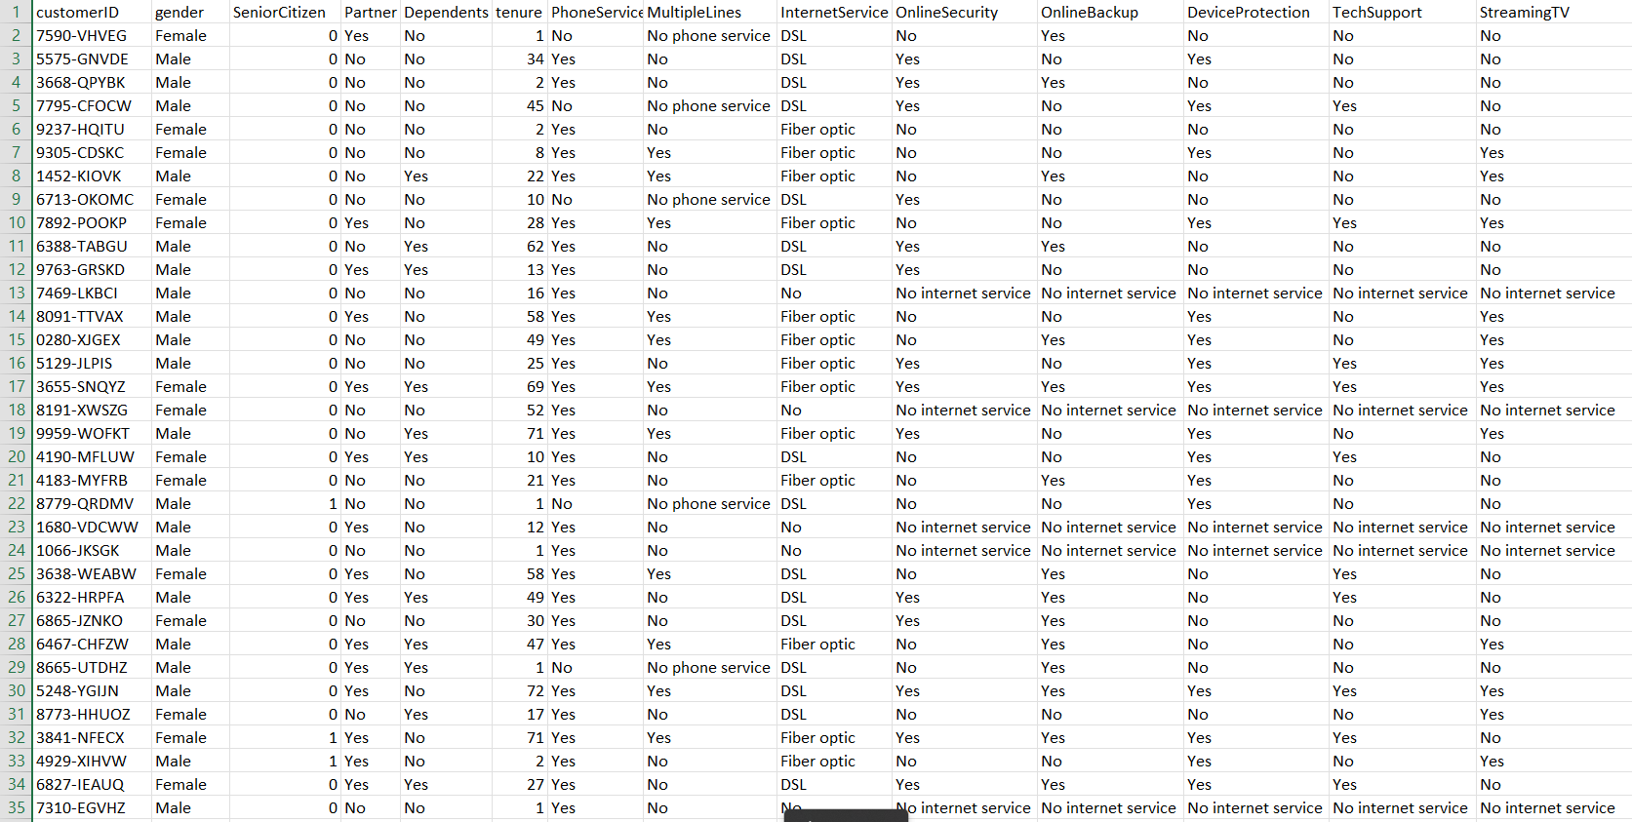

**Data Understanding:**

Explore dataset structure, types, and distributions.

**Data Cleaning:**

Handle missing values and outliers.

**Feature Engineering:**

Create, transform, or select relevant features.

**Data Visualization:**

Utilize graphs for insights and pattern recognition.

**Ensemble Methods :**

* **Decision Tree Classifier:** Decision Trees split data but may overfit, controlled with depth limits.
* **Random Forest Classifier:** Ensembles of Decision Trees reduce overfitting.
* **Pickling the model:** Serialize and save ML models for easy storage and deployment.

**Model Evaluation and Selection:** Assess model performance using metrics like accuracy, precision, recall, or ROC-AUC. Cross-validation helps select the best-performing model.

**Model Interpretability:** Understand how the model makes predictions, using techniques like feature importance analysis, SHAP values, or LIME to ensure transparency and trust.

**Deployment and Prediction:** Deploy the model in a production environment, allowing it to make real-time predictions, often through APIs or cloud-based platforms, to enhance business decision-making.

**PROGRAM :**

**In [1]:**

**import** pandas **as** pd

**from** sklearn **import** metrics

**from** sklearn.model_selection **import** train_test_split

**from** sklearn.metrics **import** recall_score

**from** sklearn.metrics **import** classification_report

**from** sklearn.metrics **import** confusion_matrix

**from** sklearn.tree **import** DecisionTreeClassifier

**from** imblearn.combine **import** SMOTEENN

**In [2]:**

df**=**pd**.**read_csv("ML Model Dataset.csv")

df**.**head()

**Out [2]:**

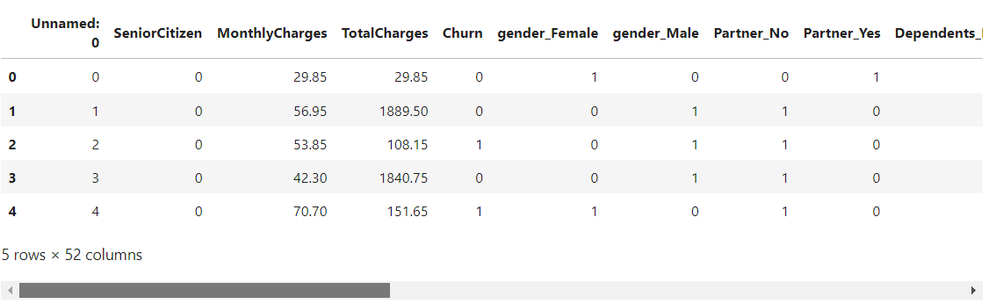

**In [3]:**

df**=**df**.**drop('Unnamed: 0',axis**=**1)

**In [4]:**

x**=**df**.**drop('Churn',axis**=**1)

x

**Out [4]:**

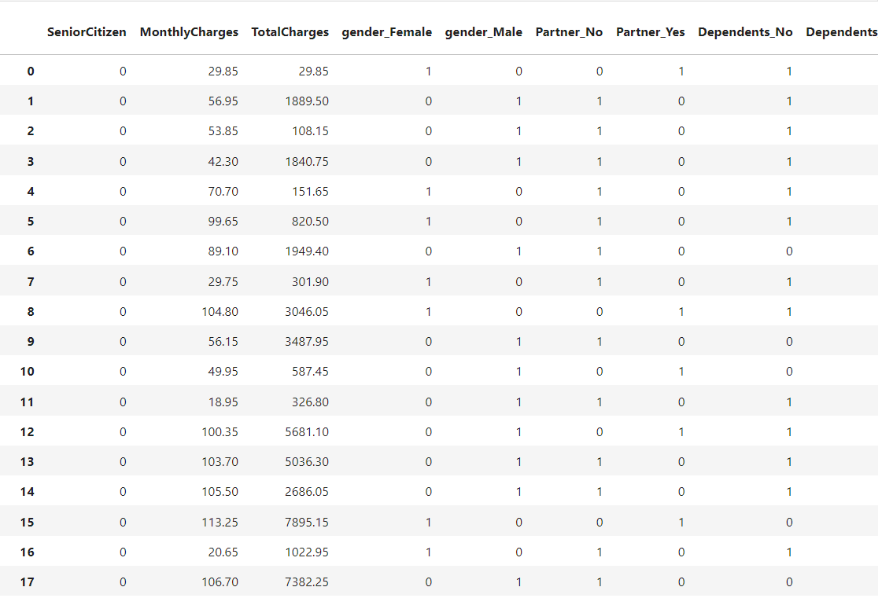

**.**

**.**

**.**

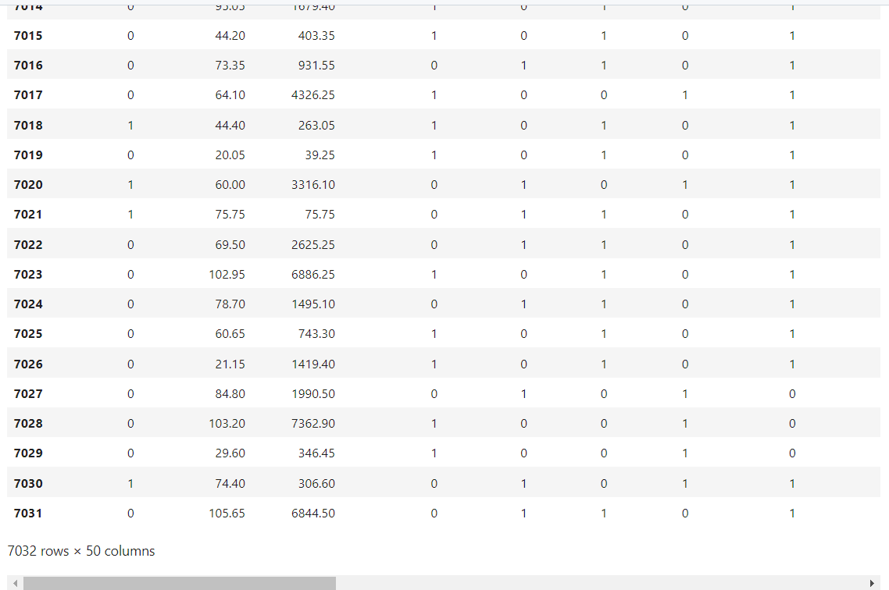

**In [5]:**

y**=**df['Churn']

y

**Out [5]:**

0 0

1 0

2 1

3 0

4 1

5 1

6 0

7 0

8 1

9 0

10 0

11 0

12 0

13 1

14 0

15 0

16 0

17 0

18 1

19 0

20 1

21 0

22 1

23 0

24 0

25 0

26 1

27 1

28 0

29 1

..

7002 0

7003 0

7004 0

7005 0

7006 0

7007 1

7008 0

7009 0

7010 1

7011 0

7012 0

7013 0

7014 0

7015 1

7016 0

7017 0

7018 0

7019 0

7020 0

7021 1

7022 0

7023 1

7024 0

7025 0

7026 0

7027 0

7028 0

7029 0

7030 1

7031 0

Name: Churn, Length: 7032, dtype: int64

##### **Train Test Split**

**In [6]:**

x_train,x_test,y_train,y_test**=**train_test_split(x,y,test_size**=**0.2)

#### Decision Tree Classifier

**In [7]:**

model_dt**=**DecisionTreeClassifier(criterion **=** "gini",random_state **=** 100,max_depth**=**6, min_samples_leaf**=**8)

**In [8]:**

model_dt**.**fit(x_train,y_train)

**Out[8]:**

DecisionTreeClassifier(max_depth=6, min_samples_leaf=8, random_state=100)

**In [9]:**

y_pred**=**model_dt**.**predict(x_test)

y_pred

**Out[9]:**

array([0, 0, 1, ..., 0, 0, 0], dtype=int64)

**In [10]:**

model_dt**.**score(x_test,y_test)

**Out[10]:**

0.7818052594171997

**In [11]:**

print(classification_report(y_test, y_pred, labels**=**[0,1]))

precision recall f1-score support

0 0.82 0.89 0.86 1023

1 0.63 0.49 0.55 384

accuracy 0.78 1407

macro avg 0.73 0.69 0.70 1407

weighted avg 0.77 0.78 0.77 1407

**In [12]:**

sm **=** SMOTEENN()

X_resampled, y_resampled **=** sm**.**fit_sample(x,y)

**In [13]:**

xr_train,xr_test,yr_train,yr_test**=**train_test_split(X_resampled, y_resampled,test_size**=**0.2)

**In [14]:**

model_dt_smote**=**DecisionTreeClassifier(criterion **=** "gini",random_state **=** 100,max_depth**=**6, min_samples_leaf**=**8)

**In [15]:**

model_dt_smote**.**fit(xr_train,yr_train)

yr_predict **=** model_dt_smote**.**predict(xr_test)

model_score_r **=** model_dt_smote**.**score(xr_test, yr_test)

print(model_score_r)

print(metrics**.**classification_report(yr_test, yr_predict))

0.934412265758092

precision recall f1-score support

0 0.97 0.88 0.93 540

1 0.91 0.98 0.94 634

accuracy 0.93 1174

macro avg 0.94 0.93 0.93 1174

weighted avg 0.94 0.93 0.93 1174

**In [16]:**

print(metrics**.**confusion_matrix(yr_test, yr_predict))

[[477 63]

[ 14 620]]

**Random Forest Classifier**

**In [17]:**

**from** sklearn.ensemble **import** RandomForestClassifier

**In [18]:**

model_rf**=**RandomForestClassifier(n_estimators**=**100, criterion**=**'gini', random_state **=** 100,max_depth**=**6, min_samples_leaf**=**8)

**In [19]:**

model_rf**.**fit(x_train,y_train)

**Out[19]:**

RandomForestClassifier(max_depth=6, min_samples_leaf=8, random_state=100)

**In [20]:**

y_pred**=**model_rf**.**predict(x_test)

**In [21]:**

model_rf**.**score(x_test,y_test)

**Out[21]:**

0.7953091684434968

**In [22]:**

print(classification_report(y_test, y_pred, labels**=**[0,1]))

precision recall f1-score support

0 0.82 0.92 0.87 1023

1 0.69 0.45 0.55 384

accuracy 0.80 1407

macro avg 0.75 0.69 0.71 1407

weighted avg 0.78 0.80 0.78 1407

**In [23]:**

sm **=** SMOTEENN()

X_resampled1, y_resampled1 **=** sm**.**fit_sample(x,y)

**In [24]:**

xr_train1,xr_test1,yr_train1,yr_test1**=**train_test_split(X_resampled1, y_resampled1,test_size**=**0.2)

**In [25]:**

model_rf_smote**=**RandomForestClassifier(n_estimators**=**100, criterion**=**'gini', random_state **=** 100,max_depth**=**6, min_samples_leaf**=**8)

**In [26]:**

model_rf_smote**.**fit(xr_train1,yr_train1)

**Out[26]:**

RandomForestClassifier(max_depth=6, min_samples_leaf=8, random_state=100)

**In [27]:**

yr_predict1 **=** model_rf_smote**.**predict(xr_test1)

In [28]:

model_score_r1 **=** model_rf_smote**.**score(xr_test1, yr_test1)

**In [29]:**

print(model_score_r1)

print(metrics**.**classification_report(yr_test1, yr_predict1))

0.9427350427350427

precision recall f1-score support

0 0.95 0.92 0.93 518

1 0.94 0.96 0.95 652

accuracy 0.94 1170

macro avg 0.94 0.94 0.94 1170

weighted avg 0.94 0.94 0.94 1170

**In [30]:**

print(metrics**.**confusion_matrix(yr_test1, yr_predict1))

[[478 40]

[ 27 625]]

#### Performing PCA

**In [31]:**

**from** sklearn.decomposition **import** PCA

pca **=** PCA(0.9)

xr_train_pca **=** pca**.**fit_transform(xr_train1)

xr_test_pca **=** pca**.**transform(xr_test1)

explained_variance **=** pca**.**explained_variance_ratio_

**In [32]:**

model**=**RandomForestClassifier(n_estimators**=**100, criterion**=**'gini', random_state **=** 100,max_depth**=**6, min_samples_leaf**=**8)

**In [33]:**

model**.**fit(xr_train_pca,yr_train1)

**Out[33]:**

RandomForestClassifier(max_depth=6, min_samples_leaf=8, random_state=100)

**In [34]:**

yr_predict_pca **=** model**.**predict(xr_test_pca)

**In [35]:**

model_score_r_pca **=** model**.**score(xr_test_pca, yr_test1)

**In [36]:**

print(model_score_r_pca)

print(metrics**.**classification_report(yr_test1, yr_predict_pca))

0.7239316239316239

precision recall f1-score support

0 0.72 0.61 0.66 518

1 0.72 0.81 0.77 652

accuracy 0.72 1170

macro avg 0.72 0.71 0.71 1170

weighted avg 0.72 0.72 0.72 1170

#### Pickling the model

**In [37]:**

**import** pickle

In [38]:

filename **=** 'model.sav'

**In [39]:**

pickle**.**dump(model_rf_smote, open(filename, 'wb'))

**In [40]:**

load_model **=** pickle**.**load(open(filename, 'rb'))

**In [41]:**

model_score_r1 **=** load_model**.**score(xr_test1, yr_test1)

**In [42]:**

model_score_r1

**Out[42]:**

0.9427350427350427

**Conclusion :**

In Phase 2, we've created a reliable model, rigorously tested it, and ensured it's easy to grasp. It's now primed for practical use in making informed decisions.